Project Code: AAE24

THE HONG KONG POLYTECHNIC UNIVERSITY

BEng(Hons) in Aviation Engineering

2023/2024

AAE4002 Capstone Project Interim Report

Development of Diversion Airport Advice System regarding to Emergency Landing

LEE Yan Tung (20063257D)

LEE Shi Shing (20050272D)

MA Ka Chun (20105376D)

|  |  |
| --- | --- |
| Academic Supervisor: | Dr. Kam K. H. NG |
| Date of Submission: | 2 January 2024 |

**Table Of Contents**

**Table Of Contents** 2

***1.*** ***Introduction*** 4

***1.1.*** ***Research Background*** 4

*1.1.1.* *Aviation Industry Overview* 4

*1.1.2.* *Cooperation Between Cockpit Crew and Air Traffic Controllers (ATC)* 4

*1.1.3.* *Possible Failure Model* 4

***1.2.*** ***Problem Description*** 5

*1.2.1.* *Human Reaction Time Under Emergency or Abnormal Situations* 5

*1.2.2.* *Standard Procedures Under Emergency or Abnormal Situations* 5

*1.2.3.* *Limitation On Real-Time Communication in Emergency or Abnormal Situations* 5

*1.2.4.* *Support To Cockpit Crew Under Emergency or Abnormal Situations* 6

***1.3.*** ***Scope*** 6

***1.4.*** ***Objectives*** 7

***1.5.*** ***Expected Deliverables*** 7

***2.*** ***Literature Review*** 8

***2.1.*** ***Human Factor in Aviation*** 8

*2.1.1.* *Task Management* 8

*2.1.2.* *Human Error* 8

***2.2.*** ***Airspaces and Standard Approach/Departure Procedures*** 10

*2.2.1.* *Class G Airspace* 10

*2.2.2.* *Standard Instrument Departures (SIDs)* 11

*2.2.3.* *Standard Terminal Arrival Routes (STARs)* 13

***2.3.*** ***Emergency Landing Technologies*** 14

*2.3.1.* *Brief introduction to emergency landing* 14

*2.3.2.* *Standard Procedure for Emergency (Airbus, 2008)* 14

*2.3.3.* *Technologies applicable for emergency landing* 17

*2.3.4.* *Currently adopted landing technologies* 18

*2.3.5.* *Limitations of landing technologies* 19

***2.4.*** ***Flight path planning*** 21

*2.4.1.* *What is flight path planning?* 21

*2.4.2.* *Elements of flight path planning* 21

*2.4.3.* *Vertical flight trajectories* 22

*2.4.4.* *Horizontal flight trajectories* 23

*2.4.5.* *Parameters of flight trajectories* 23

*2.4.6.* *Mathematical models for flight path planning* 24

*2.4.7.* *Estimated outcomes of planning* 26

*2.4.8.* *Summary on flight path planning* 28

***2.5.*** ***Failure mode for modern commercial aircraft*** 28

***2.6.*** ***OpenAP*** 30

*2.6.1.* *WRAP kinematic model* 30

***3.*** ***Methodology*** 33

***3.1.*** ***Aim of the research*** 33

***3.2.*** ***OpenAP*** 33

***3.3.*** ***Trajectory simulation*** 34

*3.3.1.* *Normal situation* 38

*3.3.2.* *Emergency or abnormal situation* 38

***3.4.*** ***Information for pilot*** 38

***4.*** ***Stage 1 - Model testing for short-haul flight*** 39

***4.1.*** ***Research*** 39

***4.2.*** ***WRAP Model*** 39

***4.3.*** ***Coding for navigation and trajectory*** 40

***5.*** ***Stage 2 - Trajectory model for long-haul flight*** 43

***5.1.*** ***Navigation section*** 43

***5.2.*** ***Trajectory of each phase*** 43

***5.3.*** ***Visualization*** 43

***5.4.*** ***Emergency or abnormal situation*** 43

***6.*** ***Reference*** 44

***7.*** ***Appendix I*** 48

1. ***Introduction***
   1. ***Research Background***
      1. *Aviation Industry Overview*

There are estimated that over 100,000 commercial aircraft fly in the world each day. In 2018 (HKCAD,2023), there were in total of 427766 take-offs or landings recorded in the Hong Kong International Airport. Before the cockpit crew starts the aircraft, flight planning would be conducted to establish the details such as route, flight path, schedule time, and fuel. The cockpit crew would also make pre-flight briefings and checks to ensure all the members know the estimated conditions, restrictions, and relevant information (e.g., Notice to Airman NOTAM) of the flight and make sure the aircraft is airworthy. Throughout the flight, the cockpit crews and the air traffic controllers in different sections continue to communicate to ensure safe and efficient operation.

* + 1. *Cooperation Between Cockpit Crew and Air Traffic Controllers (ATC)*

To perform safe and efficient operations of aircraft, in controlled airspace, ATC uses designated radio frequency to communicate with the cockpit crew. The cockpit crew coordinates the flight plan and reports position, altitude, and intention to the ATC, who in turn provides clearance, information, and instructions to maintain appropriate distances for safe aircraft operation. If an emergency occurs, air traffic controllers provide guidance and assistance to the cockpit crew while coordinating with other related parties to resolve the issue safely.

* + 1. *Possible Failure Model*

Throughout the flight, there are a variety of situations that can cause a loss of control, so an immediate safe landing is the top priority. These situations include single or dual-engine failure, abnormal flight control surfaces, and fuel starvation. When there is soul on board requires medical assistance, or any event that does not affect aircraft performance but is potentially hazardous, the cockpit crew might need assistance to divert to the best airport as soon as possible. Cockpit crews are not expected to calculate the precise performance of the aircraft in these emergencies.

* 1. ***Problem Description***
     1. *Human Reaction Time Under Emergency or Abnormal Situations*

The Human Reaction Time varies differently depending on the specific situation and the individual proficiency of the cockpit crew. A team of well-trained and experienced cockpit crew should have a high sense of situational awareness and a high familiarity with the procedures, to adapt to the real-time situation and make correct decisions quickly. However, there is still a gap of time which might be crucial to the safety of aircraft. In the case of Hudson Miracle, pilots in the simulator could successfully land on all nearby runways when they eliminated all the human reaction time in the simulations.

* + 1. *Standard Procedures Under Emergency or Abnormal Situations*

When there the aircraft is abnormal, the cockpit crew first needs to determine the situation, then settle to a consensus before deciding which final decision would be endorsed by the captain. Then the cockpit crew would make distress or urgency calls as required by the ATC to gain support from them. The ATC will then enquire about information and the situation on the radio while discussing the solution, such as available alternate airport/runway with the cockpit crew. The pilot then attempts to reference the procedures of the Quick Reference Handbook and Flight Manual to eliminate existing problems. If there is a lack of time, the pilots will attempt to look for a nearby safer ground to make an emergency landing.

* + 1. *Limitation On Real-Time Communication in Emergency or Abnormal Situations*

ATC and cockpit crew use Very High Frequency (VHF) as their communication radio. However, radio signals might still be distorted or weakened due to distance, terrain, weather situation, etc. Clear and reliable communication between the cockpit and the ground might be difficult to establish in emergencies. At the same time, radio congestion might occur when there is high volume of radio transmissions in the same channel. This could delay the request and support between the cockpit and the ground. Although there may be emergency frequencies in some areas for use in emergencies, these channels still cannot guarantee smooth communication between pilots and the ground. Simplicity in conversation might be crucial when the quality of radio communication is limited.

* + 1. *Support To Cockpit Crew Under Emergency or Abnormal Situations*

In an emergency or abnormal situation, the cockpit crew is busy gaining control of the aircraft or executing emergency procedures as mentioned above, and the communication between ATC and cockpit crew should be simple and direct to reduce workload and distractions. Furthermore, commercial flights could be flying in non-controlled airspace (Class G Airspace), where ATCs are not available to assist and give recommendations to the aircraft in emergencies. Moreover, aircraft in emergencies also need to coordinate with other nearby aircraft in Class G Airspace, which greatly increases the workload of the cockpit.

* 1. ***Scope***

This paper studies real-time diversion airport advice systems regarding emergency landings. The current plan of A320 pilots to handle abnormal situations is to reference the Emergency and Abnormal procedures (EAC) in the Quick Reference Handbook (QRH). The system based on the initial aircraft conditions, converts them into parameters and determines the possible flying route while creating possible trajectories to the runways nearby. It could lower the workload of the cockpit crew as pilots could save time in finding nearby airports and available runways. The cockpit crew could suggest the ideal runway to ATC and gain support from the ground while focusing on the emergency or abnormal procedures to eliminate the unsafe issue.

This paper reviews the concept of Air Traffic Management and human factors when cockpit crew handling abnormal and emergencies. The development of algorithm and parameters references from the Open Model for Aircraft Performance and Emissions developed by Dr. Junzi Sun.

* 1. ***Objectives***

This project mainly focuses on the following objectives:

* To collect and analyze real-time aircraft status data.
* To examine the farthest effective flight distance using the real-time data of the aircraft to determine
* To develop an algorithm calculating the best landing airport option and its flight path through real-time flight data
* To determine whether the system could reduce human reaction time when facing an emergency.
  1. ***Expected Deliverables***

A real-time diversion airport advice system will be proposed in this research. The system is based on the condition of the aircraft to suggest the possibility of landing in nearby runways.

The framework includes the following:

* Conduct a literature review on human reactions during emergencies
* Develop a program to obtain and analyze real-time aircraft mechanical and dynamical data
* design algorithm method to compute the most appropriate and effective flight path for the available airport design and develop a panel for display
* Test the program and invite personnel to conduct flight with the panel in the simulator
* Analyze the result by comparing the performance between simulations

1. ***Literature Review***
   1. ***Human Factor in Aviation***
      1. *Task Management*

Aviate, navigate, and communicate are the three important elements of flight implementation in search of the flying instinct (Katerinakis, T., 2014). Aviate refers to the pilots use of the skills to maintain control of the aircraft; Navigate refers to the pilots knowing where the aircraft is and finding out where it intends to go as destination; Communicate refers to pilots communicating with third parties such as Air Traffic Controllers, Companies, Ground Services. The most important and prioritized part is Aviate, in which pilots must control the aircraft in emergency or abnormal situations before complying with other actions, then navigate, know where the aircraft land should be, and finally communicate with the ATC. The diversion advisory system could assist pilots in the Navigation stage, reducing the time required to explain the situation to ATC and look for possible runways one by one.

* + 1. *Human Error*

Human error is one of the contributing factors in around 70% to 80% of aviation accidents (Sarter, N. B., & Alexander, H. M.,2000). There are a few types of human errors, including skill-based errors, knowledge-based errors, and rule-based errors.

Skill-based error in aviation refers to pilots making mistakes related to the procedure skills or physical abilities without conscious thinking. It happens when the pilots do their well-practiced tasks, such as in practiced emergencies and it is more likely to happen when pilots are fatigued, distracted or under stressful circumstances.

Knowledge-based errors in aviation refer to pilots not being available to handle an unusual situation. They could only resort to first principles and experience to solve problems with limited understanding and awareness of the situation. These errors are more likely to happen among the less experienced pilots when they are facing abnormal or emergency airborne.

Rule-based errors in aviation refer to the pilots applying diversly rules that had been established. These errors are more likely to happen when the rules or procedures are ambiguous, and pilots in time pressure, or without sufficient training in the specific procedure.

These 3 types of errors are not mutually exclusive, when the working environment is not ideal, such as in abnormal or emergencies, the pilots would be under pressure and loads of procedures would have to be followed. No matter whether experienced or less experienced pilots, they would have a chance to make one or a few above errors and mistakes, such as lapses and slips.

According to the study of pilots facing emergencies by Bezerra, F. G., & Ribeiro, S. L. (2012), less difficult tasks require higher physical demand while more difficult tasks require more mental demand.

**Figure 2 Difficulty Level in Different Tasks**

**(Adopted from Bezerra, F. G., & Ribeiro, S. L. ,2012)**

**Figure 1 Demand Level in Different Tasks**

**(Adopted from Bezerra, F. G., & Ribeiro, S. L. ,2012)**

In aviation, physical ability could be significantly increased by training and experience gained, while mental ability relies more on natural abilities. Although there were selection progress such as aptitude tests for future pilots to determine whether they had enough mental ability to due with highly intense situations before hiring them, there were still differences between pilot and pilot that could not be fixed by training. Therefore, to reduce stress for pilots when they are facing emergency or abnormal situations, systems should be made to reduce tasks for them to worry about. This project could reduce the workload of pilots in emergency or abnormal situations and hence reduce the possible errors made by the pilots.

* 1. ***Airspaces and Standard Approach/Departure Procedures***
     1. *Class G Airspace*

Class G airspace is the uncontrolled airspace that presents the absence of air traffic controllers to provide air traffic management services, only traffic information about other IFR and known VFR fights as far as practicable. According to the Federal Aviation Administration (2023), exists wherever that portion of airspace has not been designated as Class A, Class B, Class C, Class D, or Class E airspace. In Hong Kong Flight Information Region, class G airspace exists in the airspace indicated below.

**Figure 3 Class G Airspace in Hong Kong Flight Information Region**

**(Adopted from VATSIM, 2021)**

In Class G airspace, since there is a lack of ATCs to assist the emergency aircraft in avoiding separations, the pilots on board are required to indicate the situation, position and intention to all nearby aircraft via radio. This highly increases the workload of pilots.

* + 1. *Standard Instrument Departures (SIDs)*

Standard Instrument Departures (SIDs) are used to provide a standard route of departure from the terminal control areas to the area control area. In Hong Kong International Airport (IATA: HKG, ICAO: VHHH), the terminal control areas implement RNP 1 SIDs, where aircraft using SIDs in Hong Kong should have RNP 1 capability. For runway 07L/R, there are the SIDs (HKCAD, 2023).

**Figure 4 Runway 07 SIDs**

**(Adopted from HKCAD, 2023)**

There are also 18 noise-mitigating SIDs for runway 07R/L, which are normally for use between 1500-2300 UTC. In this project, we simulate a flight from Hong Kong (VHHH) to Sydney (YSSY), referencing a Cathay Pacific flight number CX111’s trajectory, it uses OCEAN2A SID from runway 07R. The requirement of OCEAN2A SID includes:

1. Initial climb to 5,000 ft. Expect further climb when instructed by ATC, but cross PORPA at 5,000ft or below.
2. Minimum climb gradient of 4.9% until leaving 1,400ft is required.
3. Speed restrictions of 205 KIAS or greater at PORPA and 220 KIAS until TD DVOR.

**Figure 5 Chart of OCEAN2A SID**

**(Adopted from HKCAD, 2023)**

* + 1. *Standard Terminal Arrival Routes (STARs)*

Standard Terminal Arrival Routes (STARs) are used to provide standard flight procedures of arrival from the area control areas to the terminal control area just before reaching a destination airport. In Sydney (Kingsford Smith) Airport (IATA: SYD; ICAO: YSSY), there are 6 STARs procedures including BOREE3A, BOREE3P, MARLN5, ODALE7 and RIVET3 using RNAV approach (Airservices Australia, 2022). The usual STAR procedure for a commercial aircraft from Hong Kong is BOREE3P if using runway 16R, a Cathay Pacific flight number CX111’s trajectory.

**Figure 6 Chart of BOREE3P STAR**

**(Adopted from Air Services Australia, 2022)**

* 1. ***Emergency Landing Technologies***
     1. *Brief introduction to emergency landing*

When an aircraft enters into an emergency and it is not able to continue its normal flight or otherwise may lead to serious accidents, it has to land for assistance within a short period. Some examples of emergency landing are, failure of critical parts such as engine and hydraulic system, fire onboard and urgent medical service is needed.

After the emergency is identified by the flight crew, they have to perform the emergency procedures, for example, contacting ATC with details of the emergency and finding assistance (FAA, n.d.), as well as considering of emergency landing. Once the pilots confirm that the plane is no longer suitable to maintain normal operation, it has to land at the nearest possible airport or landing zone. The factors for landing spot consideration shall include the ability and performance of the aircraft, remaining fuel, runway length, and weather conditions. While some information and instructions may be provided by the ATC.

* + 1. *Standard Procedure for Emergency (Airbus, 2008)*

In the Flight Crew Training Manual, abnormal situations are suggested, and procedures are recommended. In case there is smoke in the cabin, the main steps include anticipating and initiating diversion and smoke origin identification and fighting. “LAND ASAP” is one of the most significant points in the Quick Reference Handbook (QRH) in this situation. The procedure is shown below.

**Figure 7 SMOKE/ FUMES/ AVNCS SMOKE procedure presentation in QRH**

**(Adopted from Airbus, 2008)**

In the event of an engine failure, Autoland may still be used without one engine operating and AP utilization should be maximized to minimize crew workload. If necessary, it is traditional to conduct a manual approach and landing with one engine inoperative.

As soon as the engine failure is recognized, the PF will simultaneously:

• Set MCT on the remaining engine (largest power on the remaining engine)

• Disconnect auto throttle

• Select the speed according to the strategy

• If appropriate, select a heading to keep clear of the airway, preferably heading towards an alternate. Consideration should be given to aircraft position relative to any relevant critical point.

With all engines shut down, cockpit indications will change dramatically as the generators are disconnected. The RAT was deployed to power the emergency generator and pressurize the blue hydraulic circuit. The left-seat pilot must immediately take control of the aircraft and establish a safe flight path.

For fuel leaks, the crew should be doing fuel checks when sequencing a waypoint and at least every 30 minutes. When an engine failure occurs, the fuel leak is more difficult to detect and it requires pilots with a higher situational awareness to identify the problem. If a fuel leak is suspected, the flight crew should follow the flowing procedure.

• If the leak is positively identified as coming from the engine, the affected engine is

shut down to isolate the fuel leak and a fuel cross-feed valve may be used as required.

• If the leak is not from the engine or cannot be located, it is imperative that the cross-feed valve is not opened.

Under all the above abnormal circumstances, not only the pilots should focus on executing the tasks in the ECAMs or the flight manual, but at the moment the pilot should also identify the best airport for landing as soon as possible. When convenient, emergencies will be reported to ATC using VHF1. Depending on the situation, ATC may assist with other aircraft locations, safe directions, etc. However, if the pilots are busy handling the incoming situation, the communication between the pilots and ATCs might be less prioritized, shorter and clearer communication should be established. This project might advise pilots for a clearer and more direct conversation with ATCs in emergency or abnormal situations.

* + 1. *Technologies applicable for emergency landing*

Besides the normal emergency procedures suggested and set by the authorities or the operators, some advanced technologies are useful to the pilots for performing successful emergency landings.

Modern aircraft are equipped with an instrument landing system (ILS), in which ground signals from the runway are sent to the aircraft, leading the plane to descend in the correct heading and glide slope (Civil Aviation Safety Authority Australia, n.d.). Pilots can land the plane in low runway visual range with the aid of this technology. As guidance is provided, errors due to incorrect decisions are reduced, so it is practicable to apply ILS during an emergency landing, if flight systems are running in good condition. Pilots are able to focus more on the emergencies that happened.

To specifically tackle emergency landings, some technologies are developed or under experimentation, ensuring the safety and efficiency of such landings.

Automated Emergency Landing System (AELS) is developed and tested with fixed-wing unmanned aerial vehicle (UAV) and Cessna 172R by Warren et. al. (2015). The key component of this system is guidance, navigation, and control (GNC). To achieve this. A path planner is developed to form possible trajectories and control systems of the aircraft are simplified to reduce excessive controls and leading to more severe errors. A motion model that is widely applicable to most of the aircraft is built for the system. Also, compensation to wind factors is put into consideration, During the test, the throttle of the aircraft is set to idle as to simulate loss in thrust due to engine failure.

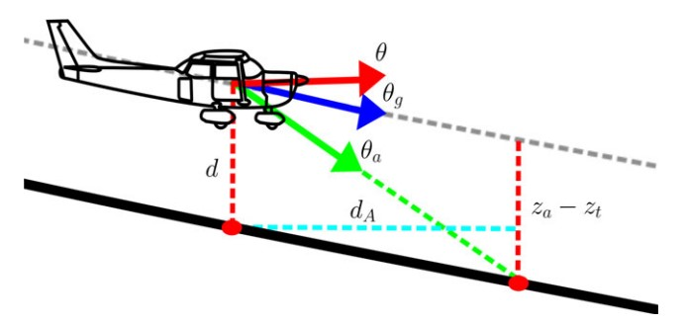The system collects, analyzes, and computes the real-time data and parameters, such as speed, altitude, motion and location obtained from the instruments of the aircraft. These data and parameters will then be input into equations to generate desirable outcomes.

**Figure 8 Pitch control model of AELS**

**(Adopted from Warren et. al., 2015)**

Pitch control is demonstrated according to the above figure. The current pitch and glide angle collected from the flight computer, and the required approach angle $θ_{a}$ is computed by the distance between the plane and the desirable path. Then the angles, and the current airspeed $V_{a}$ are inputted into the equatons of calculating the best pitch angle $θ_{U}$ a follow. $θ_{U}= P_{p}\left(P_{descent}×\left(θ_{a}- θ_{g}\right)+\min{(P_{anti-stall} ×(V_{a}}- V_{g}\right), 0))$

For the system input, the best glide speed $V_{g}$ and the gains from secondary controller, which are pitch gain $P_{p}$, descent gain $P_{descent}$ and proportional gain $P_{anti-stall}$ when the best glide speed is larger than current speed. The pitch is then controlled to a desirable level by following the result of the calculation. The roll control is also computed with a similar flow. As observed in this example of pitch control, the motion model seems applicable to other aircraft as no specific parameters for a particular aircraft are needed.

Although suitable commands are given by the AELS system, this paper also emphasizes the importance of human situational awareness and actions as emergencies are not only limited to engine failure, also the emergency in reality is uncertain, such as, the idle thrust setting in the experiment is different from actual engine failure.

* + 1. *Currently adopted landing technologies*

The AELS is not approved to be put in service, while technology company GARMIN has developed a similar system that had been approved by the FAA and has already installed in several small aircraft.

According to GARMIN (2020), the Autoland system enables the plane to land automatically even if the pilot is unable to control it. Once the pilot or passenger presses the Autoland button, a suitable landing spot will be identified by the system and navigation starts. Besides navigation and control, Autoland can also send the current location, altitude and details of emergency to the ATC. The system works automatically until the plane comes to a full stop at the landing spot, engines will also shut down automatically. The following figure shows the interface of Emergency Autoland (GARMIN, 2020). In this interface, the distance to the landing spot and the remaining flying hours according to the amount of remaining fuel are shown.

Figure 1 GARMIN Autoland system

*(Adopted from Garmin, 2020)*

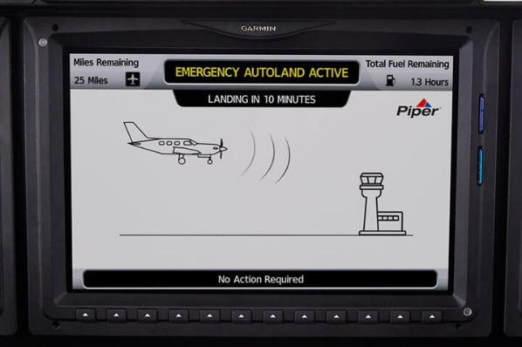If the aircraft is controllable, Autoland is not a compulsory measure to be adopted. An alternative technology is the Emergency Descent Mode (EDM) developed by the same company. It is mainly used when the pressurized system of the aircraft is failed and rapid descent to lower latitude so that people onboard can breathe normally is needed (GARMIN, 2020). Autopilot will act automatically and the plane will descend to a safe altitude. The pilot can control the plane again at this level.

**Figure 9 GARMIN Autoland system**

**(Adopted from Garmin, 2020)**

* + 1. *Limitations of landing technologies*

The systems mentioned above are adopted and tested in some small aircraft only. One key reason is that most small aircraft require only one pilot, if that pilot is not able to continue the flight, it directly leads to loss of control of that aircraft, so it is essential to develop automatic systems for these aircraft. As large commercial aircraft require at least two pilots, the above problem is eliminated, also, the mechanics, failure mode, and emergencies of these planes are more complicated, so there are no similar systems developed for them for now. Further developments and experiments in these technologies to examine the possibility of applying these technologies to large commercial aircraft are required.

According to the General Aviation and Commercial Division of FAA (n.d.), the Autoland system does not consider the NOTAM and other aerodrome information, also it does not take actions to avoid traffic, and most importantly, the system is not able to follow ATC instructions, which may pose harm to surrounding aircraft. It illustrates that these landing technologies are not comprehensive, in which pilot decisions and actions are still essential to maintain safety.

To perform emergency landing without excessive actions which may lead to human errors, considerations of using landing technologies should be carefully carried out by the pilots. Also, it is beneficial to perform flight path planning as an assistance and suggestion for pilots when practicing emergency landing (Hassan et. al., 2022).

* 1. ***Flight path planning***
     1. *What is flight path planning?*

To maintain sufficient safety level and efficiency during the whole flight process, a comprehensive flight path should be planned before the commencement of the flight. A complete flight path planning of a commercial flight should include the starting position and the destination, the desired route with waypoints, and desirable aircraft performance such as speed and altitude, with a consideration of ATC and meteorological restrictions.

Flight path plan is produced by the flight operations department of the airline and approval from the Local Aviation Authority should be obtained (Ataman, 2023). Flight path estimation can be generated based on different models and computer programs. Some prebuilt models are Base of aircraft data (BADA) and OpanAP with WRAP models. These models are accumulated with records retrieved from actual flights (Uzun et. al., 2018). Operators may also generate the plan with their program. The plan is then introduced to pilots before departure. The pilots onboard enter the flight path into the Flight Management System (FMS) and perform the flight according to the desired path. While alternations and deviations during flight are anticipated due to the temporary ATC instructions and changing weather.

By adopting different flight path planning methods in accordance with relevant instructions and limitations, flight safety can be ensured. Also, optimal flight paths can be generated by fulfilling the desirable outcomes set by the operators and pilots, especially the fuel consumption and shortened flight time, which can reduce operation and fuel costs.

* + 1. *Elements of flight path planning*

Flight path planning can be produced as the dynamic flight trajectory throughout the whole flight from takeoff to landing, and it can be divided into several sections or phrases, as the performance of the aircraft differs during these phrases, suitable inputs are essential for achieving the maximum efficiency with complying ATC instructions and without exceeding design limitation. the trajectory describes the flight path and position in three dimensions (lateral, vertical, and horizontal). With the addition of time measurement as a dimension, a 4D trajectory can be plotted (Delahaye et.al., 2014).

Normal flight phases include takeoff, climb, cruise, descent, and landing. The climb can be divided into initial climb and a normal climb, and descent can be divided into a normal descent and final approach. As ground movements are mostly directed by ATC, and they post little effect on efficiency, the rolling before takeoff and after landing is not put into consideration in planning.

The basic flight path planning can be divided into vertical and horizontal segments and used for vertical navigation (VNAV) and lateral navigation (LNAV) respectively. Performance according to takeoff, climb, descent and landing are mostly included in the vertical segment. The consideration of choosing waypoints and appropriate courses is computed in the horizontal segment. In some models, velocity trajectory will also be generated (Jiang et.al., 2021).

* + 1. *Vertical flight trajectories*

Takeoff and climb can be computed together from the takeoff position to the top of the climb. After takeoff, the plane starts climbing. The plane cannot directly climb and descent to the desired cruise level due to fuel efficiency, separation scheme and altitude limits, and avoid steep climb angle leading to discomfort. Different climb phases can be applied to fulfill the desirable outcomes. Also, descent and landing can be combined and computed with several descent phases.

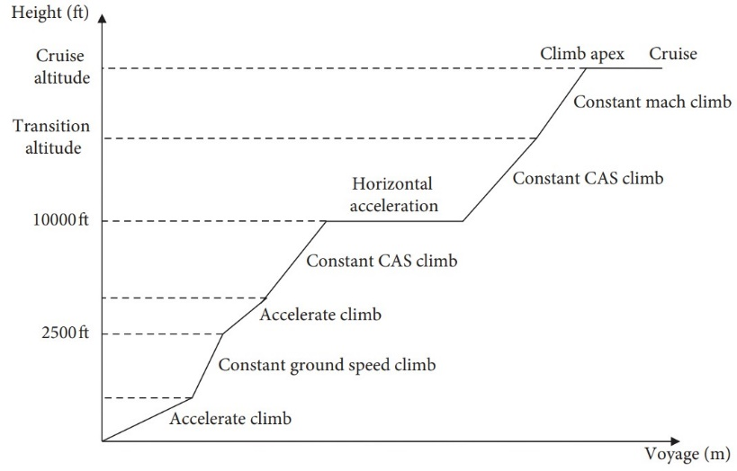

**Figure 10 Example of phases of takeoff and climb**

**(Adopted from Jiang et.al., 2021)**

As observed in the figure above (Jiang et.al., 2021), the phases of ascending are not computed with a straight line but with some steps and horizontal movement, similar approach is used for descent. This phase model is adopted in several performance and simulation models, such as OpenAP.

* + 1. *Horizontal flight trajectories*

The consideration of flight routes regarding the starting and ending positions, and the waypoints are defined as horizontal flight trajectories. During path planning, the cruise phase, which is the flight phase between top of the climb to top of the descent, is the main component of horizontal flight trajectories. Unlike climb and descent, this phase contains fewer alternations of altitude, while the factors affecting this phase are mainly weather, especially wind (Félix Patrón & Kessaci, 2014). As aircraft in this phase is at the highest speed and altitude, the wind direction and magnitude variation post great impacts on airspeed, varying fuel efficiency. Also, alternation of course and direction is needed in accordance with airspace restrictions and ATC requirements. To determine the performance during cruise, different flight path calculations is needed to be adopted among waypoint by using different inputs.

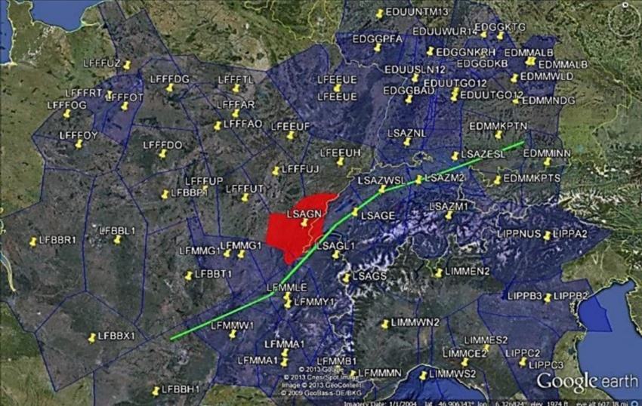

**Figure 11 Example of horizontal trajectories**

**(Adopted from Gardi et.al., 2016)**

* + 1. *Parameters of flight trajectories*

To generate an appropriate fight path for a particular aircraft, correct parameters are chosen and input for accurate estimation. Each parameter has its maximum, minimum value based on aircraft design limitations, and mean value, which can be assumed as the optimal values accumulated from previous flights.

Basic parameters of aircraft include takeoff and landing weight, altitude, distances for takeoff and landing, fuel quantity and fuel flow, airspeed and vertical speed and the range. Different values and units of the parameters are used during different flight phases due to the expected performance, while there is no common standard to decide what values should be used (Koyuncu et. al., 2018).

For example, different airspeed values and units are used for different phases. For takeoff, climbing, descending and landing, calibrated airspeed (CAS) and true airspeed (TAS) are used for estimation as the aircraft performance is mostly affected by engine output and this speed accurately represent it. When the plane is reaching or in cruise phase, besides CAS and TAS, airspeed in Mach can be used, as the plane is at high speed, also Mach number is more suitable for describing the airspeed in situation under varying air density, hence more accurate estimation on engine performance, calculation on fuel flow. While the Mach number cannot be directly measured but calculated by the airspeed equation as follow.

$$M= \frac{V_{tas}}{a_{0}\sqrt{\frac{T}{T_{0}}}}$$

After obtaining the TAS from the aircraft, with the ISA temperature and speed of sound (${T_{0 }and a}_{0}$), also with the current temperature at level, Mach number can be estimated.

* + 1. *Mathematical models for flight path planning*

To plan a complete flight path with essential aircraft dynamic movements, suitable parameters are put into equations for computation. Basically, integrations are used as the flight path is a combination of continuous estimation, and matrixes are used to determine the motion of the aircraft (Soler et. al., 2015). While different calculations and equations are adopted in separate models, as each model have their own outcomes.

For basic trajectory estimation, the following equation can be used.

$$l(γ) =\int_{a}^{b}{|\left|γ^{'}\left(t\right)\right||dt}$$

The length of the trajectory $l(γ)$ can be estimated by the change of time of the movement from point a to b (Delahaye et.al., 2014). This is the optimal curvature path without consideration of other factors, so it may not be absolutely applied in all models. For example, in the WRAP model used in this project, straight-line segments between waypoints are adopted to reduce calculation time.

An approach to estimate the trajectory with its total fuel flow at that segment for assessing the flight cost, which is Compromised Aircraft performance model with Limited Accuracy (COALA) is as follows.

$$T_{i}= \{{lon}_{i}, {lat}_{i}, {alt}_{i}, {TAS}_{i}, {Phase}_{i}, ṁ_{f,i}, m_{gas,i}\}$$

In this function, longitude, latitude, altitude, TAS, the specific value for each flight phases, the fuel flow rate and the gas emissions are utilized to estimate the path (Rosenow et.al., 2021). This approach is more feasible to be used in computer programming as only numeric inputs, which are the values at the particular flight phase are required.

As observed in these two examples, it is assumed that with similar outcomes, calculation methods between different models are varying, it is essential to focus on the methods in the particular model that is chosen for this project, which is the WRAP model, to reduce bias and errors.

In WRAP model, the parameters are described by the continuous probability density functions (PDF), the parameter values can be represented in curvature graphic format, and the overall description of the parameter is as follow.

$$\{\hat{ψ}\left|ψ_{min},ψ_{max}\right|*pdf\}$$

The $\hat{ψ}$ is the optimal value, and $ψ_{min},ψ_{max}$ are the minimum and maximum values respectively (Sun et.al., 2018). Suitable values are selected to be input into the functions. Combinations of parameters are collected through the programming process and hence trajectory can be generated.

In the WRAP model, to achieve efficient calculation, simple calculations are used. One example is that the distance of takeoff, $D_{tof}$, can be calculated as follow.

$D_{tof}=R×\arccos{[sinϕ_{1}}×sinϕ_{N}+cosϕ_{1}×cosϕ_{N}×cos⁡(λ_{N}-λ_{1})$]

With the R is the radius of the earth, $ϕ$ and $λ$ are the latitude and longitude in radian, 1 and N is the position of the start and the end of takeoff according to the data retrieved from ADS-B (Sun et.al., 2018).

As WRAP model is a package with sufficient built-in mathematical models and equations, also with the basic information and parameters of the aircraft, its engines and the properties of the airports, it is more important to identify the flight phases and segments and select the correct parameters to input into the functions.

* + 1. *Estimated outcomes of planning*

After selecting and inputting sufficient and correct parameters, with the estimated aircraft condition, such as payload, a complete flight path plan with essential predictions is made. The graphs and curves generated depend on the desirable outcomes.

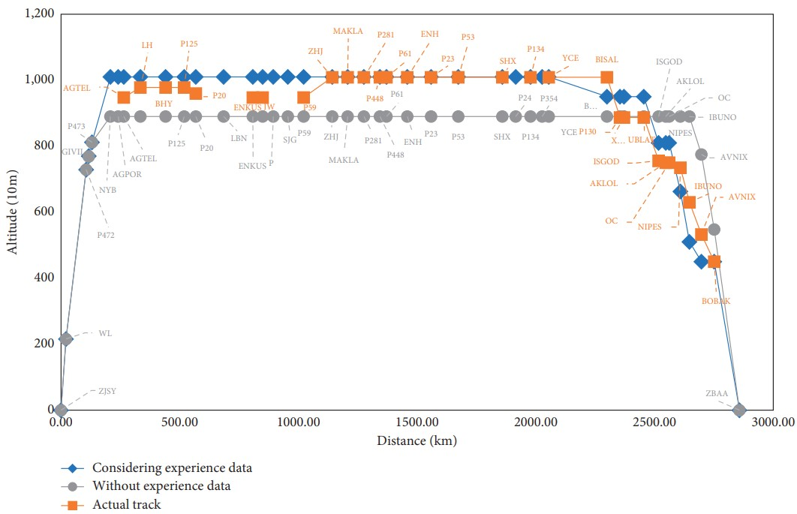The following example is the complete trajectory from takeoff to landing of an aircraft, with the consideration of altitude as and distance, also with the waypoints (Jiang et. al., 2021). The total flying distance and maximum cruising level can be observed in this trajectory. The three trajectories in different colors represents that the usage of data, and the process of simulation will make the trajectory different from the actual performance. Also, as observed in the optimal and actual paths, some waypoints are eliminated from the actual flight comparing to the desired track.

**Figure 12 Flight trajectory with altitude and distance**

**(Adopted from Jiang et. al., 2021)**

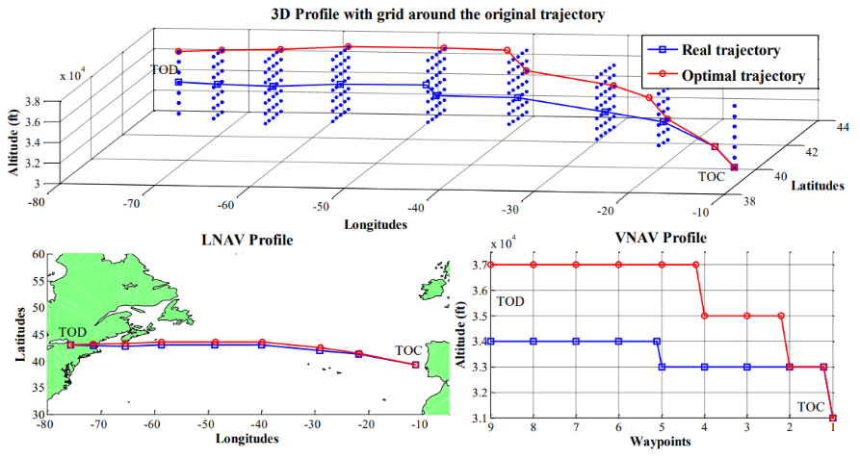Another example made by Patrón and Botez (2015) represents both the horizontal and vertical trajectories with waypoints recorded of an aircraft during its top of climb (TOC) and top of descent (TOD). The example illustrates the horizontal paths used for LNAV with latitudes and longitudes, and vertical paths used for VNAV with the altitude. The 3D trajectory is generated by combining the horizontal and vertical paths. Similar to the example above, the optimal and actual trajectories are shown in different colors. It is observed that the altitude control of the pilot deviates from the optimal path.

**Figure 13 Completed 3D trajectory combined with horizontal and vertical trajectories**

**(Adopted from Patrón and Botez, 2015)**

As observed in both examples made by different expertise, trajectories are integrated with the optimal trajectory, which is calculated and generated with existing experience data, also the real trajectory which is performed by the aircraft is shown. These two trajectories differ from each other and may give different values on fuel consumption and flight time. The estimated, optimized trajectory may deviate due to actual restrictions such as traffic, unexpected weather such as turbulence at level which alternation of altitude is needed, and the onboard decision of the pilot according to the situation mentioned above. Course, waypoints passing through, airspeed and altitude in actual flight are not necessary to be completely followed according to the desirable path due to these factors. Also, emergency procedures will result in severe deviation on optimal flight path, as additional control on large scale, such as emergency descent with great slope, will be applied.

* + 1. *Summary on flight path planning*

The publications with their results and discussions reveal that flight path planning provides clear scope to the operators and pilots on how to maximize the performance of the aircraft by analysis of data and estimation. While this plan is not the only basis for the pilots to complete a flight, but also the real situations and instructions, especially when the plane enters into emergency.

* 1. ***Failure mode for modern commercial aircraft***

To consider whether emergency landing is needed, the type of failure must be identified. For modern aircraft, most of the emergency landing cases are caused by serious system or equipment failure and threat of human onboard (Ezzat, 2020).

Some common system or equipment failures during flight include hydraulic loss (Palomeque, 2017), fuel leak, single/dual engine failure or fire, Electronic Centralized Aircraft Monitor (ECAM) failure (for Airbus aircraft), smoke or fire onboard (Haroon, 2023). These failures may affect the normal operation of the aircraft and may lead to difficulty in control by pilot.

Once the component is found failed, cautions and warning signals will be active to alert the pilots. Also, flight control systems, such as Fly-by-wire, also detect and receive failure signals (Dolega & Rogalski, 2008). These signals are helpful to determine the required parameters to be input for the flight path planning if available.

Among the parameters of the flight path planning, the engine performance parameters are the most vulnerable to failures, as most of the severe abnormal or emergency situations are related to engine failures.

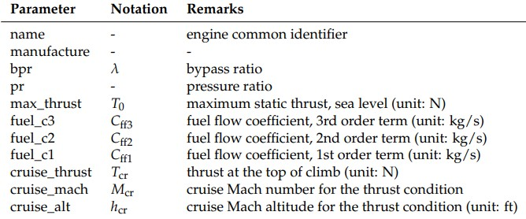From the above figure, it is assumed that under the abnormal situation, the engine parameters will not be at their optimal level. If there is fuel leak, the fuel flow coefficient can be assumed be at its minimum value. For the engine malfunction, the thrust parameter can be assumed as minimum.

**Figure 13 Engine parameters in OpenAP model**

**(Adopted from Sun et.al., 2018)**

It is not guaranteed that the parameters are affected with this intensity, or the minimum parameters are not enough to represent the emergency. It is better to obtain the most updated data and information from the flight control system for precise computing for the flight plan. Also, pilots are needed to maintain awareness throughout the whole emergency process.

* 1. ***OpenAP***

Several Aviation Authorities and companies have developed aircraft performance model for air transport research. For instance, General Aircraft Modelling Environment (GAME) and BADA were developed by Eurocontrol. (OpenAP) Most of them are limited to license users. OpenAP is an open-source model that can be used as an alternative for air transportation studies and simulations. It is based on open aircraft surveillance data, such as surveillance-broadcast (ADS-B) and Enhanced Mode-S (EHS), and open literature models to simulate the properties, kinematic performance, dynamic performance and utilities of the aircraft. Other information such as flight phase and aeronautical calculation are also practical in OpenAP.

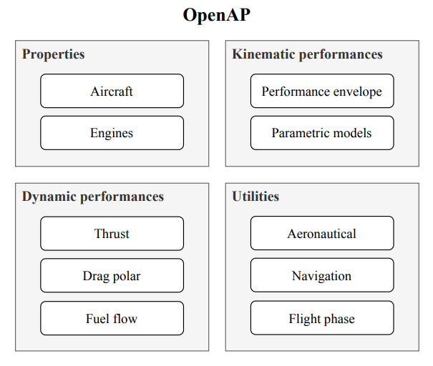

**Figure 14 Components in OpenAP**

**(Adopted from Sun et.al., 2020)**

* + 1. *WRAP kinematic model*

For the kinematic performance, OpenAP uses WRAP to construct aircraft model in different flight envelopes. WRAP is a data-driven statistical model that studies the aircraft motions. The model contains database giving the basic aircraft performance parameters. The value of the parameters is based on real data. With the open data value, the aircraft simulation will be more precise and closer to the reality situation. The parameters are defined by the flight phase as shown below. (Sun et.al, 2018)

|  |  |
| --- | --- |
| Takeoff | |
| Liftoff speed ($m/s$) | $$V_{lof}$$ |
| Takeoff distance ($km$) | $$d_{lof}$$ |
| Mean takeoff acceleration ($m/s^{2}$) | $${\overline{a}}_{lof}$$ |
| Initial climb | |
| Calibrated airspeed ($m/s$) | $$V_{cas,ic}$$ |
| Vertical rate ($m/s$) | $${VS}_{ic}$$ |
| Cutoff altitude (fixed at 457m/1500ft) | $$h_{ic}$$ |
| Climb | |
| Range to the top of climb ($km$) | $$R_{top,cl}$$ |
| Constant CAS across altitude ($km$) | $$h_{cas,cl}$$ |
| Constant CAS ($m/s$) | $$V_{cas,cl}$$ |
| Vertical rate during constant CAS climb ($m/s$) | $${VS}_{cas,cl}$$ |
| Constant Mach climb crossover altitude ($km$) | $$h_{mach,cl}$$ |
| Constant Mach number | $$M_{cl}$$ |
| Vertical rate during constant Mach climb ($m/s$) | $${VS}_{mach,cl}$$ |
| Cruise | |
| Cruise range ($km$) | $$R_{cr}$$ |
| Maximum cruise range ($km$) | $$R_{max,cr}$$ |
| Initial cruise altitude ($km$) | $$h_{int,cr}$$ |
| Cruise altitude ($km$) | $$h_{cr}$$ |
| Maximum cruise altitude ($km$) | $$h_{max,cr}$$ |
| Cruise Mach number | $$M_{cr}$$ |
| Maximum cruise Mach number | $$M_{max,cr}$$ |
| Descent | |
| Range from the top of descent ($km$) | $$R_{top,de}$$ |
| Constant Mach number | $$M_{de}$$ |
| Constant Mach descent crossover altitude ($km$) | $$h_{mach,de}$$ |
| Vertical rate at constant Mach descent ($m/s$) | $${VS}_{mach,de}$$ |
| Constant CAS ($m/s$) | $$V_{cas,de}$$ |
| Constant CAS crossover altitude | $$h_{cas,de}$$ |
| Vertical rate at constant CAS descent ($m/s$) | $${VS}_{cas,de}$$ |
| Vertical rate after constant CAS descent ($m/s$) | $${VS}_{postcas,de}$$ |
| Final approach |  |
| Calibrated airspeed ($m/s$) | $$V_{cas,fa}$$ |
| Vertical rate ($m/s$) | $${VS}_{fa}$$ |
| Cutoff altitude (fixed at 300m/1000ft) | $$h_{fa}$$ |
| Path angle | $$∠_{fa}$$ |
| Landing |  |
| Touchdown speed ($m/s$) | $$V_{tcd}$$ |
| Braking distance ($km$) | $$d_{lnd}$$ |
| Mean braking deceleration () |  |

* 1. ***Visualization of flight path using KML format***

Flight trajectory is constructed with numerical values and 2D graphs inside Python. It is more efficient for pilots to obtain graphical data that geographical features located along the flight path can be acknowledged as references. To enable display of this type of data, Keyhole Markup Language (KML) file can be generated through Python.

KML file is a tool to transfer dimensional information such as latitude, longitude and time to graphical data. Once the KML file is constructed through programming software, it can be opened and projected in several earth browsers such as Google Earth (Google Developers, n.d.).

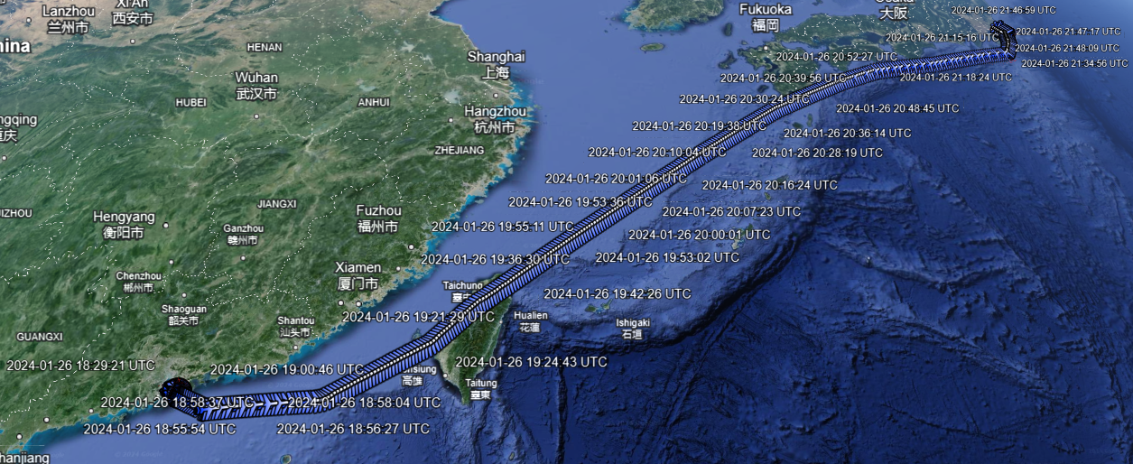The following figures are representing the flight trajectory of HX606 which is chosen for the sample flight for stage one of this project. The KML file is prepared by FlightRadar24 by collecting ADS-B data from the flight. The file is opened with Google Earth and the flight trajectory is visualized. When users click on the airplane icon with UTC time shown, the altitude, location, speed and heading at that specific period can be shown.

Figure XX Full flight trajectory of HX606 at 26 January 2024

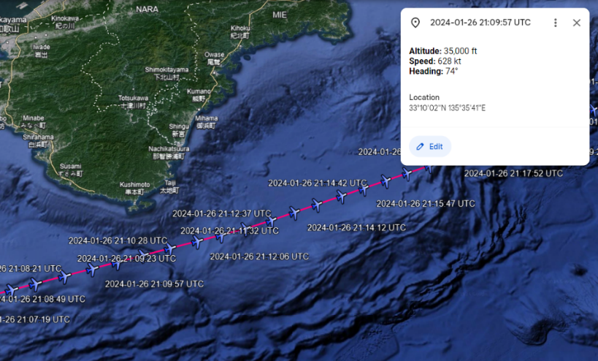

Figure XX Flight information displayed from KML file

The KML file can be built and adjusted through programming software. The following example is one of the “Placemark” code for a single point of the flight trajectory. The placemark will be transformed into the plane icon in Google Earth.

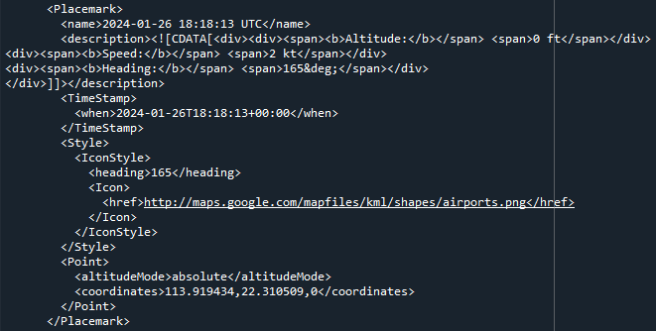

Figure XX Placemark code for a point that HX606 filed through

The code defines the information showed and its format on the browser. Programmer has to input the time recorded, heading and location of the flight. Also, FlightRadar24 has defaulted the file is to be read by Google Earth, as the link typed into the program states that the graphic reference for the airplane icon is from Google Maps.

Comparing to data tools such as Excel files, KML files are more flexible and user-friendly. Excel files are effective to store data and for data processing, while it is a proprietary file format built by Microsoft, and only can be opened and processed by mainstream operating system such as Windows and iOS. Alternatively, KML is a format built with the standard of Extensible Markup Language (XML), which is a non-proprietary format, the file contains standardized text data that can be processed by various software (Pierre, 2012). Besides Google Earth, KML files can be opened with several online map services, such as Marble and Global Mapper (Fisher, 2023). Users can open the file with the suitable application or software based on their needs and hardware specification.

As KML enables visualization of data, it becomes an efficient tool for users to obtain data. As data originally presented as numeric values are gathered and transformed into graphic data, the data processing and analysis by user is eliminated (Gramazio et al., 2014), which reduces search time and errors occurred by wrong observations of numerical data.

To project the flight trajectory to pilots, especially in emergency situations which reaction time is limited with less or even no-fault tolerance, KML file is the suitable format. Pilots can search and locate their positions with regard of time, also to search for landscape for the purpose of checkpoints, which is useful when flight instruments are in malfunction. Also, several software and application that can process KML files can be prepared in cockpit, serving as redundant, instead of using a single software to open the files.

1. ***Methodology***
   1. ***Aim of the research***

Human failure is one of the major reasons that failure occurs in operation. With the evolution of the AI technology, less experienced pilots are more likely to perform weaker in emergency situation due to the dependence on technology. Integrating the model with the aircraft system can provide optimal solutions for pilots during emergency landing. In an emergency or abnormal situation, every second is crucial. To enhance the pilot performance, such as reaction time and decision making, during emergency situations by reducing the possibility of human error, we aim to simulate the parametric model of the aircraft motion in several phases by using the open-source kinematic aircraft performance model, WRAP. Using the model, an optimal path for the pilot can be estimated by visualizing the flight path and providing the essential information for emergency, for example: required fuel amount, and distance with nearest airport.

* 1. ***OpenAP***

OpenAP is an open-source aircraft performance model for air transportation studies and simulations (available at: <https://github.com/tudelft-cns-atm/openap>). It provides OpenAP packages with Python packages and model data. The packages, includes the aircraft data, engine data, kinematic data and navigation data such as airport and waypoint. For the Python library, it includes 11 Python coding packages.

|  |  |
| --- | --- |
| Packages | |
| Prop | Accessing aircraft and engine properties |
| Thrust | Computing aircraft thrust |
| Drag | Computing aircraft drag |
| Fuel | Computing fuel consumption |
| Emission | Computing aircraft emission |
| Kinematic | Accessing WRAP data |
| Aero | Common aeronautical conversions |
| Nav | Accessing navigation information |
| Segment | Determining climb, cruise, descent, level flight |
| Phase | Identify the flight phases |
| Traj | Tools for trajectory generation. |

* 1. ***Trajectory simulation***

|  |  |
| --- | --- |
| Situation | |
| Flight | CX111 |
| Destination | HKG-SYD |
| Duration | 8.5 hours |
| Aircraft type | A350 |

In this paper, we will focus on exploring an A350 flight CX111 flying from Hong Kong to Sydney. It is an 8.5 hours flight passing above ocean and small islands. A long haul flight allows us to perform a more precise simulation with different terrain and more airport options for emergency. To simplify the simulation routine of the flight CX111. The path will be cut into pieces by the waypoints to estimate the flight path in each phase such as climb and cruise. The picture below shows the flight path of CX111 in normal situation. The path will be cut into 8 parts to calculate the variation in each section. As the model only allow point to point calculation, each part is divided to be as straight line as possible to minimize the calculation error. The flight will be separated into 8 phases, which are takeoff, climb, initial climb, climb, cruise, descent, final approach and landing. Default flight data from the WRAP model will be used as the input parameter of the formula.

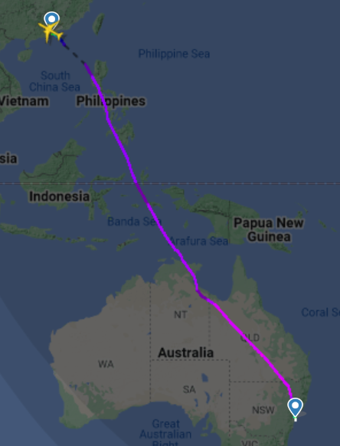

**Figure 15 Flight path (Flightradar24)**

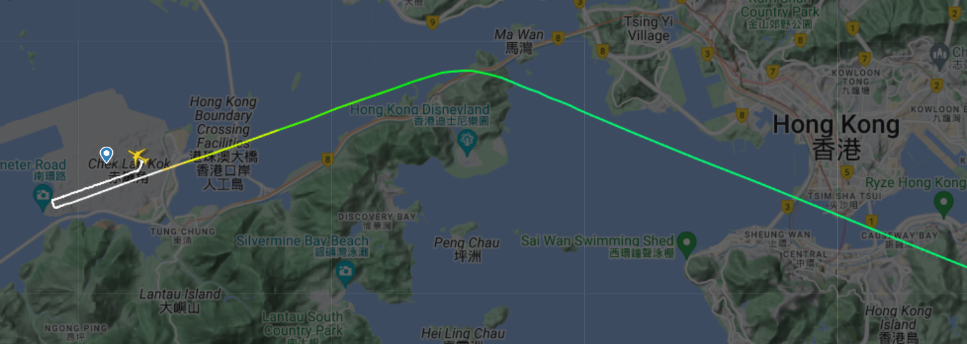

**Figure 16 Waypoint: PORPA (Phase 1) (Flightradar24)**

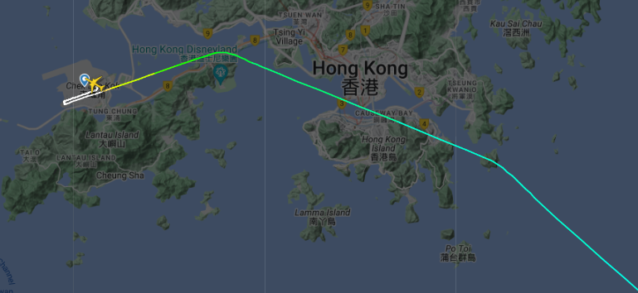

**Figure 17 Waypoint: TD (Phase 2) (Flightradar24)**

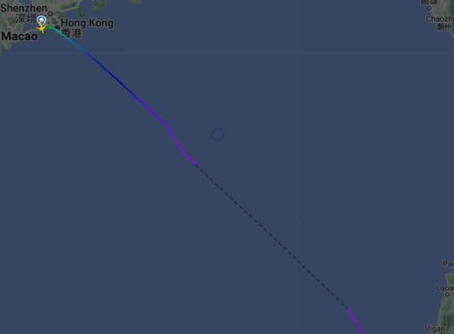

**Figure 18 Phase 3 (Flightradar24)**

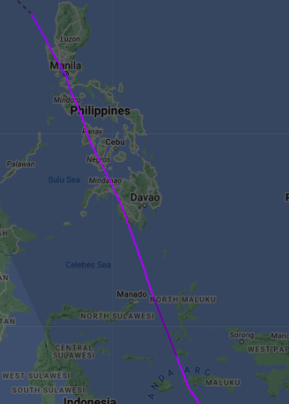 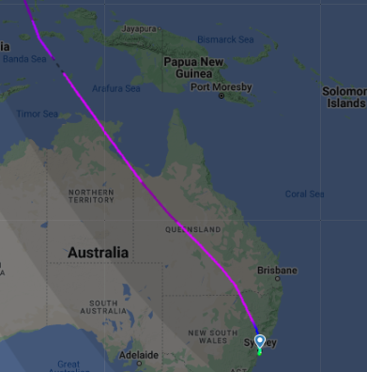

**Figure 19 Phase 4 (Flightradar24)**   **Figure 20 Phase 5 (Flightradar24)**

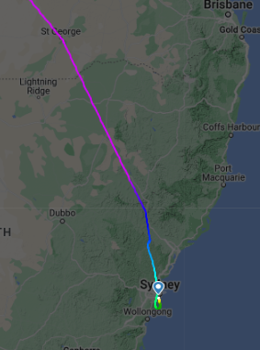 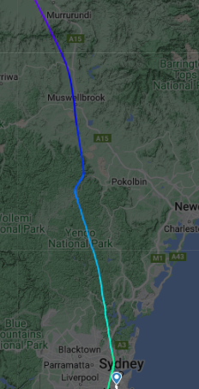

**Figure 21 Phase 6 & 7 (Flightradar24) Figure 22 Phase 8 (Flightradar24)**

* + 1. *Normal situation*

Trajectory of flight in normal situations will be made and compared with the real flight data from Flightradar24 to ensure the simulation is accurate and precise. WRAP model will be used to help generate coding for the trajectory and calculation of the crucial information for pilot.

* + 1. *Emergency or abnormal situation*

After ensuring the coding is precise for calculation and path simulation, abnormal situation will be added to the model to simulate the new flight path according to the current aircraft situation. Three Abnormal situations will be added to estimate the real situation during the flight. They are one engine failure, two engine failure and fuel leakage. To simplify the simulation, each failure has its assumption.

|  |  |
| --- | --- |
| Failure | Assumption |
| One engine failure | Half of the thrust loss |
| Dual engine failures | Full thrust loss |
| Fuel leakage | Constant leakage rate |

* 1. ***Information for pilot***

As mentioned before, the simulation is used to reduce the human error made during flight especially in emergency situation. Therefore, after simulating the aircraft condition during the emergency situation such as amount of fuel needed until the aircraft arrive at the airport, distance that aircraft can go on in this situation, the system will calculation and display the top 3 nearest airport nearby. Airport that located at latitude $±2$ and longitude $±2$ will be selected into the calculation. The location of the airports and the distance between the aircraft and the airport will be displayed for the pilot's consideration. Information like fuel amount needed and estimated arrival time will also be shown for pilot reference. The path will be visualized for the pilot for further elaboration.

1. ***Stage 1 - Model testing for short-haul flight***

For aviation accidents, almost 80% of fatal general aviation accidents are caused by pilot error. (*Nasa, 2013*) There are numerous factors that pilots have to face in emergency situations. For example, communication with another pilot, navigation and workload. Hence, we aim to design a flight performance model that estimates the optimal flight path for the pilot in an emergency situation.

* 1. ***Research***

Before designing the model, we researched the factors that will affect the pilot performance by focusing on studying the literature regarding to the emergency in flight such as human factors, emergency landing procedures, and current technology for an emergency landing. It allows us to understand the possible support pilot needed for urgent situations. Then, we can decide which essential information we need to display to reduce the information process workload for pilots in urgent situations. For instance, the distance between current location and the nearest airport, estimated time of arrival, the location and code of the nearest three airports and estimated fuel amount for landing.

* 1. ***WRAP Model***

In this paper, we integrate the OpenAP model Python code (available at: https://github.com/tudelft-cns-atm/openap) along with our own code to form a model for emergency. In the model code, there are countless functions used for modeling the aircraft performance. To familiarize ourselves with the model coding, we have chosen a shorter path for aircraft performance in the preliminary stage.

|  |  |
| --- | --- |
| Situation | |
| Flight | HX606 |
| Destination | HKG-NRT |
| Duration | 3.5 hours |
| Aircraft type | A320 |

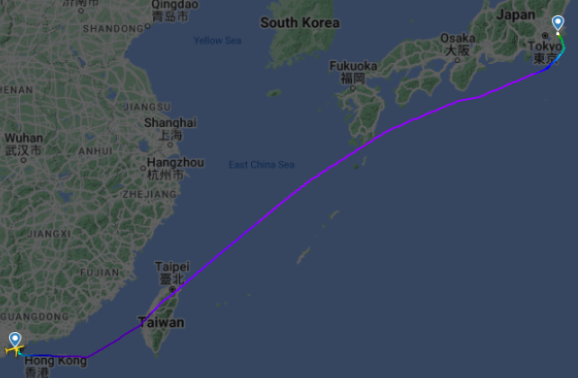

**Figure 23 Flight path: HKG-NRT (Flightradar24)**

* 1. ***Coding for navigation and trajectory***

With the Python packages, we try to generate coding for forming the flight path. As mentioned previously, OpenAP provides performance parameters based on real flight data, Enhanced Mode S Surveillance (EHS) data and ADS-B data. Default value will be used for each parameter in the coding as the mass of each flight and engine performance are different. The coding is attached to Appendix I.

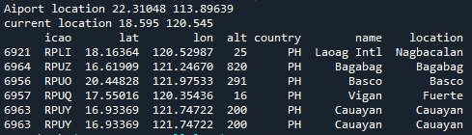

**Figure 24 Navigation result**

In the current progress, the location of the selected airport can be shown in radian. With OpenAP packages, we can list the nearby airports of a certain location. As shown in the figure, we use latitude 18.595 and longitude 120.545 as the current location of an aircraft. Airports that are located at [Equation] of latitude and longitude. Other information such as the airport name, location and altitude of the aircraft will also be shown for pilot reference.

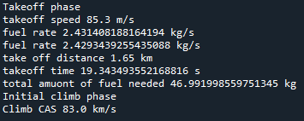

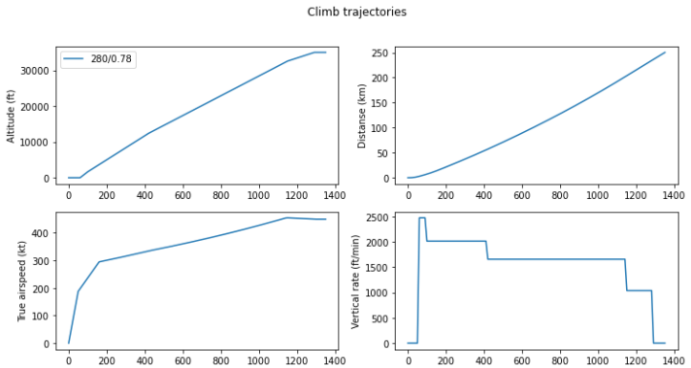

**Figure 25&26 Trajectory result**

From the coding in Appendix I, default performance parameters are used for further calculation for the phase. In the takeoff phase, we calculated the fuel rate at altitude = 0ft and altitude = 50ft. As the fuel rate at altitude = 0ft is larger than altitude = 50ft, to avoid the situation of underestimating the fuel usage, larger value should be used to play safe. Hence, we encountered a problem when we are calculating the climb phase. We are confused about what parameters we need to be calculate to generate the trajectory. From the second picture, there is a climb trajectory generated from the Python packages provided in OpenAP.



**Figure 27 Coding from Appendix**

To use the coding in OpenAP, we first need to input the climb situation of the aircraft so that the WRAP model can help to calculate the phase data. However, as the input data is constant, we need to revise the coding again to understand the calculation in the coding and the correct parameters we needed for simulation. Therefore, in the preliminary process, we are still studying the python packages in OpenAP. We believe that once we acquire the knowledge inside the packages, we will have rapid growth in designing the diversion airport advice system.

1. ***Stage 2 - Trajectory model for long-haul flight***
   1. ***Navigation section***

In the next stage, we are going to calculate the distance between the current location and the selected airport. Then, we can further calculate the fuel amount needed and estimate arrival time. Information can be used to provide more precise navigation data for the pilot.

* 1. ***Trajectory of each phase***

We will also need to generate the trajectory of each phase for calculating the fuel usage, change of bearing and traveling distance. To ensure the accuracy and precision of the generated trajectory, the generated trajectory will be used to compare with the real-time data from flightradar 24. After confirming, we can estimate the location of the kinematic aircraft using the data calculated above. Then, we can apply the navigation part to find the nearest airport.

* 1. ***Visualization***

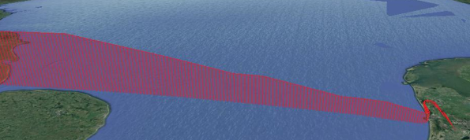After finding the nearest airport, we aim to visualize the flight path for the pilot in 3D in the cockpit panel. An example is shown below.

**Figure 28 Visualized 3D flight path**

**(Adopted from Stackoverflow, 2016)**

* 1. ***Emergency or abnormal situation***

Subsequently, we can input the emergency data into the finished model and simulate the situation. As mentioned before, there will be three emergencies included in this paper. They are single, dual engine failure and fuel leakage. For a single engine failure, half of the thrust will be lost. For dual engine failure, all thrust will be lost. Lastly, fuel leakage will be at a constant rate.

With this system, it will help to decrease the workload for pilot in emergency situations and the possibility of human error.

1. ***Reference***

Airbus. (2008, July 8). A320/321 flight crew training manual - 737NG. <https://www.737ng.co.uk/A320%20321%20FCTM%20Flight%20Crew%20Training%20Manual.pdf>

Airbus. (2022, May). *Airbus 320 family main FCOM QRH FCTM changes*. A320 Examiner. <https://www.737ng.co.uk/A320%20321%20FCTM%20Flight%20Crew%20Training%20Manual.pdf>

Civil Aviation Safety Authority Australia. (n.d.-a). Operational notes of instrument landing system. [https://www.casa.gov.au/sites/default/files/2021-09/operational-notes-on-instrument-landing-system.pdf](https://www.casa.gov.au/sites/default/files/2021-09/operational-notes-on-instrument-landing-system.pdf%20)

Dancila, B. D., & Botez, R. M. (2018). Vertical flight path segments sets for aircraft flight plan prediction and optimization. In The Aeronautical Journal (Vol. 122, Issue 1255, pp. 1371–1424). Cambridge University Press (CUP). <https://doi.org/10.1017/aer.2018.67>

Delahaye, D., Puechmorel, S., Tsiotras, P., & Feron, E. (2014). Mathematical models for aircraft trajectory design: A survey. In Lecture Notes in Electrical Engineering (Vol. 290). Springer Japan. DOI: 10.1007/978-4-431-54475-3__12

D. G. Beeftink, C. Borst, D. Van Baelen, M. M. van Paassen and M. Mulder, "Haptic Support for Aircraft Approaches with a Perspective Flight-Path Display," 2018 IEEE International Conference on Systems, Man, and Cybernetics (SMC), Miyazaki, Japan, 2018, pp. 3016-3021, DOI: 10.1109/SMC.2018.00512.

Dolega, Boguslaw & Rogalski, Tomasz. (2008). Diagnostics of fly‐by‐wire control system. Aviation. 12. 41-45. 10.3846/1648-7788.2008.12.41-45.

Ezzat, I. (2020, July 3). *Aircraft emergency landing*. Aviation Nuggets. <https://aviationnuggets.com/blog/30/aircraft-emergency-landing>

Federal Aviation Administration. (n.d.). Instrument procedures handbook. [https://www.faa.gov/sites/faa.gov/files/regulations_policies/handbooks_manuals/aviation/instrument_procedures_handbook/FAA-H-8083-16B_Front_Page.pdf](https://www.faa.gov/sites/faa.gov/files/regulations_policies/handbooks_manuals/aviation/instrument_procedures_handbook/FAA-H-8083-16B_Front_Page.pdf%20)

Garmin International. (n.d.). Fd Tech Services. [https://www8.garmin.com/aviation/brochures/FD-Tech-Services.pdf](https://www8.garmin.com/aviation/brochures/FD-Tech-Services.pdf%20)

General Aviation and Commercial Division, Federal Aviation Administration. (n.d.). Emergency Autoland Overview. [https://www.faasafety.gov/files/events/WP/WP07/2021/WP07104435/Emergency_Autoland_Overview_Flyer.pdf](https://www.faasafety.gov/files/events/WP/WP07/2021/WP07104435/Emergency_Autoland_Overview_Flyer.pdf%20)

Haghighi, H., Delahaye, D., & Asadi, D. (2022). Performance-based emergency landing trajectory planning applying meta-heuristic and Dubins paths. Applied Soft Computing, 117, 108453. <https://doi.org/10.1016/j.asoc.2022.108453>

Hong Kong Virtual Area Control Centre (HKVACC). (2021, December 1). *STANDARD OPERATING PROCEDURES (SOP)*. Virtual Air Traffic Simulation Network (VATSIM). <https://vathk.com/pdf/HKVACC-SOP051-R3.pdf>

*How to make a flight path projection if possible in python?*. Stack Overflow. (2016, July 28). <https://stackoverflow.com/questions/38507069/how-to-make-a-flight-path-projection-if-possible-in-python>

Jiang, S.-Y., Luo, X., & He, L. (2021). Research on Method of Trajectory Prediction in Aircraft Flight Based on Aircraft Performance and Historical Track Data. Mathematical Problems in Engineering, 2021, Article ID 6688213, 1-11. <https://doi.org/10.1155/2021/6688213>

Kellaway, D. A. (2022). *Aviate, Navigate, Communicate!: DX-inspired pilot - ATC exchange training.* Daiichi Institute of Technology. [https://kagoshima.daiichi-koudai.ac.jp/](https://kagoshima.daiichi-koudai.ac.jp/%20)

K.Haroon. (2023, September 1). *A320 abnormal procedures*. The Airline Pilots. <https://www.theairlinepilots.com/forumarchive/a320/a320-abnormal-procedures.pdf>

M. Uzun, M. Umut Demirezen, E. Koyuncu and G. Inalhan, "Design of a Hybrid Digital-Twin Flight Performance Model Through Machine Learning," 2019 IEEE Aerospace Conference, Big Sky, MT, USA, 2019, pp. 1-14, DOI: 10.1109/AERO.2019.8741729.

Palomeque, M. (2017, June 4). *A320 - dual hydraulic loss - Airbus*. Safety First Magazine - issue 4. <https://safetyfirst.airbus.com/app/themes/mh_newsdesk/documents/archives/a320-dual-hydraulic-loss.pdf>

Patrón, R. S. F., & Botez, R. M. (2015). Flight Trajectory Optimization Through Genetic Algorithms for Lateral and Vertical Integrated Navigation. In Journal of Aerospace Information Systems (Vol. 12, Issue 8, pp. 533–544). American Institute of Aeronautics and Astronautics (AIAA). <https://doi.org/10.2514/1.i010348>

Patrón R. S. F., Kessaci A, Botez RM. Horizontal flight trajectories optimisation for commercial aircraft through a flight management system. *The Aeronautical Journal*. 2014;118(1210):1499-1518. DOI:10.1017/S0001924000010162

Rosenow, J., Lindner, M., & Scheiderer, J. (2021). Advanced Flight Planning and the Benefit of In-Flight Aircraft Trajectory Optimization. In Sustainability (Vol. 13, Issue 3, p. 1383). MDPI AG. <https://doi.org/10.3390/su13031383>

Shively, J. (n.d.). *If human error is the cause of most aviation accidents, should we ...* Ames Research Center. [https://ntrs.nasa.gov/api/citations/20190001065/downloads/20190001065.pdf](https://ntrs.nasa.gov/api/citations/20190001065/downloads/20190001065.pdf%20)

Soler, M., Olivares, A., & Staffetti, E. (2015). Multiphase Optimal Control Framework for Commercial Aircraft Four-Dimensional Flight-Planning Problems. In Journal of Aircraft (Vol. 52, Issue 1, pp. 274–286). American Institute of Aeronautics and Astronautics (AIAA). <https://doi.org/10.2514/1.c032697>

Sun, J., Hoekstra, J. M., & Ellerbroek, J. (2020). OpenAP: An Open-Source Aircraft Performance Model for Air Transportation Studies and Simulations. In Aerospace (Vol. 7, Issue 8, p. 104). MDPI AG. <https://doi.org/10.3390/aerospace7080104>

Sun, J., Kaufmann, N., Alleon, G., JulienneJ, & jfuellgraf. (n.d.). *Tudelft-CNS-atm/openap: Open aircraft performance model and python toolkit*. GitHub. [https://github.com/TUDelft-CNS-ATM/openap](https://github.com/TUDelft-CNS-ATM/openap%20)

Warren, M., Mejias, L., Kok, J., Yang, X., Gonzalez, F., & Upcroft, B. (2015). An Automated Emergency Landing System for Fixed-Wing Aircraft: Planning and Control. Journal of Field Robotics, 32(8), 1114-1140. DOI: 10.1002/rob.21641.

1. ***Appendix I***

***Flight_path_try1***

import os

import numpy as np

import skfuzzy as fuzz

import csv # read excel

import matplotlib.pyplot as plt # plot graph

from openap import FlightPhase # flight phase

#from openap import CruiseOptimizer # optimal situation for time and fuel (opt)

from openap import nav # find the location of the waypooint/airport

from openap.traj import Generator # for gen traj

from openap import WRAP # kinematic

from openap import FuelFlow # fuelflow

from openap import Thrust # thrust

from openap import aero # unit in SI unit

from math import sin, cos, sqrt, atan2

"""unit

1 knot = 1.852 km/h

"""

#initial every used Class (_init_)

fuel= FuelFlow(ac='A320', eng='CFM56-5B4')

wrap= WRAP(ac='A320')

thrust= Thrust(ac='A320', eng='CFM56-5B4')

phase= FlightPhase()

gen= Generator(ac='A320', eng='CFM56-5B4')

#takeoff 0ft-50ft (0-35ft)

#speed & change

print('Takeoff phase')

takeoffspeed= wrap.takeoff_speed()["default"]

print('takeoff speed',takeoffspeed,'m/s')

fuel_rate= fuel.takeoff(tas=takeoffspeed*1.94384449, alt=0, throttle=1) #knot, ft, 0-1 (1 full thrust)

print('fuel rate',fuel_rate,'kg/s')

fuel_rate= fuel.takeoff(tas=takeoffspeed*1.94384449, alt=50, throttle=1)

print('fuel rate',fuel_rate,'kg/s')

takeoffdistance= wrap.takeoff_distance()["default"]

print('take off distance',takeoffdistance,'km')

takeofftime= (takeoffdistance*1000)/takeoffspeed

print('takeoff time',takeofftime,'s')

Total_fuel_amount_takeoff = takeofftime*fuel_rate

print('total amuont of fuel needed',Total_fuel_amount_takeoff, 'kg')

# intial climb (35-15kft) (15-454.5m)

print('Initial climb phase')

climb_cas= wrap.initclimb_vcas()["default"]

print('Climb CAS',climb_cas, 'km/s')

# climb (10k-50k)

#generating 4 graph for climb trajectories

fig, ax = plt.subplots(2, 2, figsize=(12, 6))

plt.suptitle("Climb trajectories")

for i in range(1):

#climb situation

data_cl = gen.climb(dt=10, cas_const_cl= 280, mach_const_cl=0.78, alt_cr=35000)

#graph 1

ax[0][0].plot(

data_cl["t"],

data_cl["h"] / aero.ft,

label="%d/%.2f" % (data_cl["cas_const_cl"], data_cl["mach_const_cl"]),

)

ax[0][0].set_ylabel("Altitude (ft)")

#graph 2

ax[0][1].plot(data_cl["t"], data_cl["s"] / 1000)

ax[0][1].set_ylabel("Distanse (km)")

#graph 3

ax[1][0].plot(data_cl["t"], data_cl["v"] / aero.kts)

ax[1][0].set_ylabel("True airspeed (kt)")

#graph 4

ax[1][1].plot(data_cl["t"], data_cl["vs"] / aero.fpm)

ax[1][1].set_ylabel("Vertical rate (ft/min)")

#label position

ax[0][0].legend()

plt.show()

# cruise (For A320, max= )

# descent ()

# Final aproach (last 1000ft)

#landing (alt=0)

***Navigation***

from openap import nav

import os

import pandas as pd

import numpy as np

from openap.extra import aero

import csv

#Location of airport

airportloc= nav.airport("VHHH")

airport_lat= airportloc["lat"]

airport_lon= airportloc["lon"]

print('Aiport location',airport_lat, airport_lon)

#lat and lon calculation (find out nearest airport)

lat= 18.595

lon= 120.545

print('current location',lat,lon)

airports = pd.read_csv('P:/FYP/openap-master/openap/data/nav/airports.csv')

df = airports[airports['lat'].between(lat-2, lat+2) & airports['lon'].between(lon-2, lon+2)]

coords = np.array(df[['lat', 'lon']])

dist2 = np.sum((coords - [lat, lon])**2, axis=1)

#get all airport

idx = np.array(dist2)

ap = df.iloc[idx, :]

print(ap)